EXPERIMENT 2
IMPLEMENTION OF MONOALPHABETIC CIPHER

Aim:
To implement the Monoalphabetic Substitution Cipher using Python.

Algorithm:
• Read the plaintext.
• Define the substitution key.
• Replace each letter using the key.
• Display the encrypted text.
• Perform decryption.
• Display the decrypted text.

Code:
plain_alphabet = "ABCDEFGHIJKLMNOPQRSTUVWXYZ"
cipher_alphabet = "QWERTYUIOPASDFGHJKLZXCVBNM"
plaintext = input("Enter Plain Text: ").upper()

encrypted = ""
decrypted = ""
for ch in plaintext:
if ch in plain_alphabet:
index = plain_alphabet.index(ch)
encrypted += cipher_alphabet[index]
else:
encrypted += ch
for ch in encrypted:
if ch in cipher_alphabet:
index = cipher_alphabet.index(ch)
decrypted += plain_alphabet[index]
else:
decrypted += ch
print("\nEncrypted Text :", encrypted)
print("Decrypted Text :", decrypted)

Output:
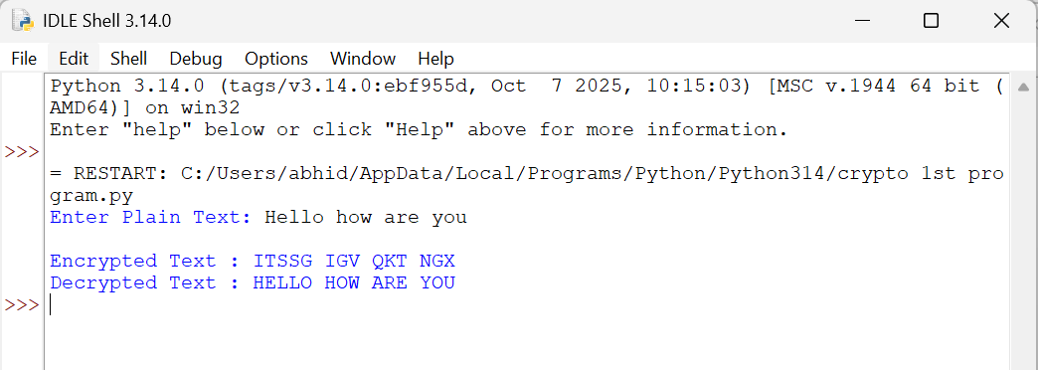

Result:
Thus, the Monoalphabetic Substitution Cipher was implemented successfully
using Python

